HOMES FOR UKRAINE VISA QUESTIONS
- Do you have a valid international Ukraine passport?
Answer: Yes or No
- What category are you applying for (Ukrainian family scheme or Homes for Ukraine?
Answer:
- What type of sponsor do you have? Organisation or Individual?
Answer:
- Were you living in Ukraine on the 31 December 2021?
Answer: Yes or No
- Does your sponsor have permission to be in the UK for more than 6 months?
Answer: Yes or No
- Which best describes your sponsor? (British Citizen/Settled in UK with settled status/Refugee with protection rights in UK/Person with pre-settled status/None of the above?
Answer:
- After pressing save and continue you will be taken to a screen that asks for an email address and password, suggest if you are completing the visa application on behalf of the person applying for the visa you use your email address and set the password so you can go back to the application, you can also supply this information to the applicant.
- Sponsors given name?(inc middle name and family name)
Answer:
- Is at least one member in your family group a Ukrainian?
Answer: Yes or No
- What is your sponsors country of nationality?
Answer: British Citizen (If this is the case)
- What is your sponsors date of birth?
Answer:
- What is your sponsors passport number?
Answer:
- What is the country of issue for your sponsors passport?
Answer: United Kingdom (if this is the case)
- Issue and expiry date of sponsors passport?
Answer: Issue Date: Expiry Date:
- Sponsors phone number?
Answer: mobile:
- Sponsors email address?
Answer:
- Has your sponsor ever been known by any other name?
Answer:
- Is your sponsor’s address in the UK?
Answer: Yes Post Code: House name and number: Street Name:
Local authority: Country within UK:
- When did they start living at this address?
Answer:
- What is your sponsors sex as shown on their passport?
Answer:
- What is their relationship status?
Answer:
- Has your sponsor ever held any other citizenship or nationality? (if yes enter details)
Answer:
- Will you be staying at the residential address of your sponsor?
Answer: Yes
- Will there be any other people living at this address where you will be staying? (Tell us about the people aged over 18 inc given name/family name/date of birth/nationality/passport number) REPEAT process for all persons aged over 18 in the sponsors house.
Answer: 2 other persons over the age of 18
  - Full Name DOB , Nationality Passport Number
  - Full Name DOB , Nationality Passport Number
- What is your email address?
Answer:
- What is your phone number?
Answer: from uk dial
- Can we contact you on this number? (select type i.e. calls, SMS/SMS only/no calls or SMS/only calls)
Answer:
- If providing more than one e-mail or phone number you will be asked which is the best to contact you on.
Answer:
- Which email address should we use to to tell you about: any questions we have/the decision/after you have been approved and whilst you are in the UK?
Answer:
- What is your given name and family name?
Answer:
- Have you ever been known by any other name?
Answer:
- What is your sex as shown on your passport?
Answer:
- What is your relationship status (married/single/widow/divorced etc.)
Answer:
- Address (use English alphabet)
Answer:
- Do you have a passport? (This must be an international passport. Do Not provide details of a domestic passport.)
Answer:
- Passport Number?
Answer:
- Passport issuing authority?
Answer:
- Passport issue and expiry date?
Answer: issue date expiry date
- Country of Nationality?
Answer:
- Country of birth?
Answer:
- Place of birth?
Answer:
- Date of birth?
Answer:
- Have you held any other nationality or citizenship (give details)
Answer:
- Do you have any family members applying with you?
Answer:
- What is their relationship to the sponsor?
Answer:
- Given name of person travelling with you?
Answer:
- Family name of person travelling with you
Answer:
- Date of birth of person travelling with you?
Answer:
- Are they travelling with you to the UK
Answer:
- What is their nationality?
Answer:
- What is their passport number?
Answer:
- Do you have any other family members you want to add (repeat above steps 42 – 48)
Answer:
- Date you plan to arrive in the UK (if you don’t know put a goal date)
Answer:
- Confirm whether you have ever been: refused visa, refused entry at border, refused asylum, deported etc?
Answer:
- Confirm that you have not entered the UK illegally, remained in the UK beyond validity of visa, breached conditions i.e. workedin UK without permission etc?
Answer:
- Check the box if applicable for: Criminal convictions, driving penalty/offence, arrest or charge awaiting trial, cautions, warning or reprimand or civil court judgement against you?
Answer: Criminal Convictions YES or NO =
Answer: Driving Penalty or Driving Offence YES or NO =
Answer: Arrest or charge awaiting trial YES or NO =
Answer:Cautions if so what cautions =
Answer:Warning or Reprimand if so what for =
Answer: Civil Court Judgement against you if so what for =
- Have you ever undertaken paid or un-paid activity on behalf of a non-UK government known to be dangerous to UK national security?
Answer: YES or NO
- Have you ever engaged in other activities which may indicate you are not a person of good character?
Answer: YES or NO
- Is there any other information about your character or behaviour that we should be aware of?
Answer: YES or NO
- Have you ever worked for: Armed Forces, government, intelligence services, security organisations, inc. police and private security, media organisations, judiciary?
Answer: YES or NO =
- Confirm you have the documents to prove identity and other documents such as:
  - Evidence you were living in Ukraine before the 01 January 2022 such as a utility bill?
Answer: Utility bill needed to prove this
  - Proof of identity of your sponsor already given passport number
Answer: Yes – Passport Number
  - Birth Certificate also required if applying for a child AND a letter from both parents giving permission to apply for visa – even if those parents are travelling with the child.
Answer:
  - Note: Evidence is uploaded via a different screen at the end of the process. Please note it will only allow upload of files in pdf format
- Confirm you understand conditions, namely: you will have conditions of your visa and if you stay in the UK without permission you can be detained, prosecuted, fined, imprisoned, removed and banned from returning, not be able to work, rent a home, claim benefits, access NHS for free, cannot have a bank account and DVLA will prevent you from driving.
Answer: Yes I understand conditions
- Confirm who has completed the form: Applicant over 18/Applicant under 18/Parent or legal guardian/Other (In doing so you are agreeing to disclaimer pertaining to the best of your knowledge all information is being correct, agreeing to the terms and conditions and the way in which the data provided will be used, And that you understand you can be prosecuted if you provided false information.
Answer: Other
  - For other you will need to answer what capacity you are supporting i.e. family member/travel agent/other. When selecting other you will be given a free text box to explain the reason you are completing. We noted this is due to forms only being available in English, unreliable internet connection in Ukraine etc. it will also ask your name, address, email and contact number.
Answer: I am the Sponsor, the forms are in English and the person I am sponsoring does not speak much English, she is also currently under bombardment at different times of the day and has an unreliable internet connection in Ukraine, I have gotten all the questions off the UK RAINE web site and completed them and then emailed them through to the visa applicant who has then completed the answers and emailed them back to me, I can confirm all documents supplied are a true record to the best of my knowledge and understanding and I have permission to complete the visa application on behalf of the applicant.
  - 3RD PARTY DETAILS
Name:
Address:
Email:
Contact Number:
- SAVE AND CONTINUE – AT THIS POINT YOU CAN NO LONGER EDIT YOUR ANSWERS, up until this point you can go back and make edits.
APPLICATION SUBMITTED SCREEN
E-mail confirmation generated to your inbox
Then move through to other screen, select download checklist to see what sort of documents are needed, you may not be able to get all of these get what you can together and scan them into pdfs

Then click on provide documents

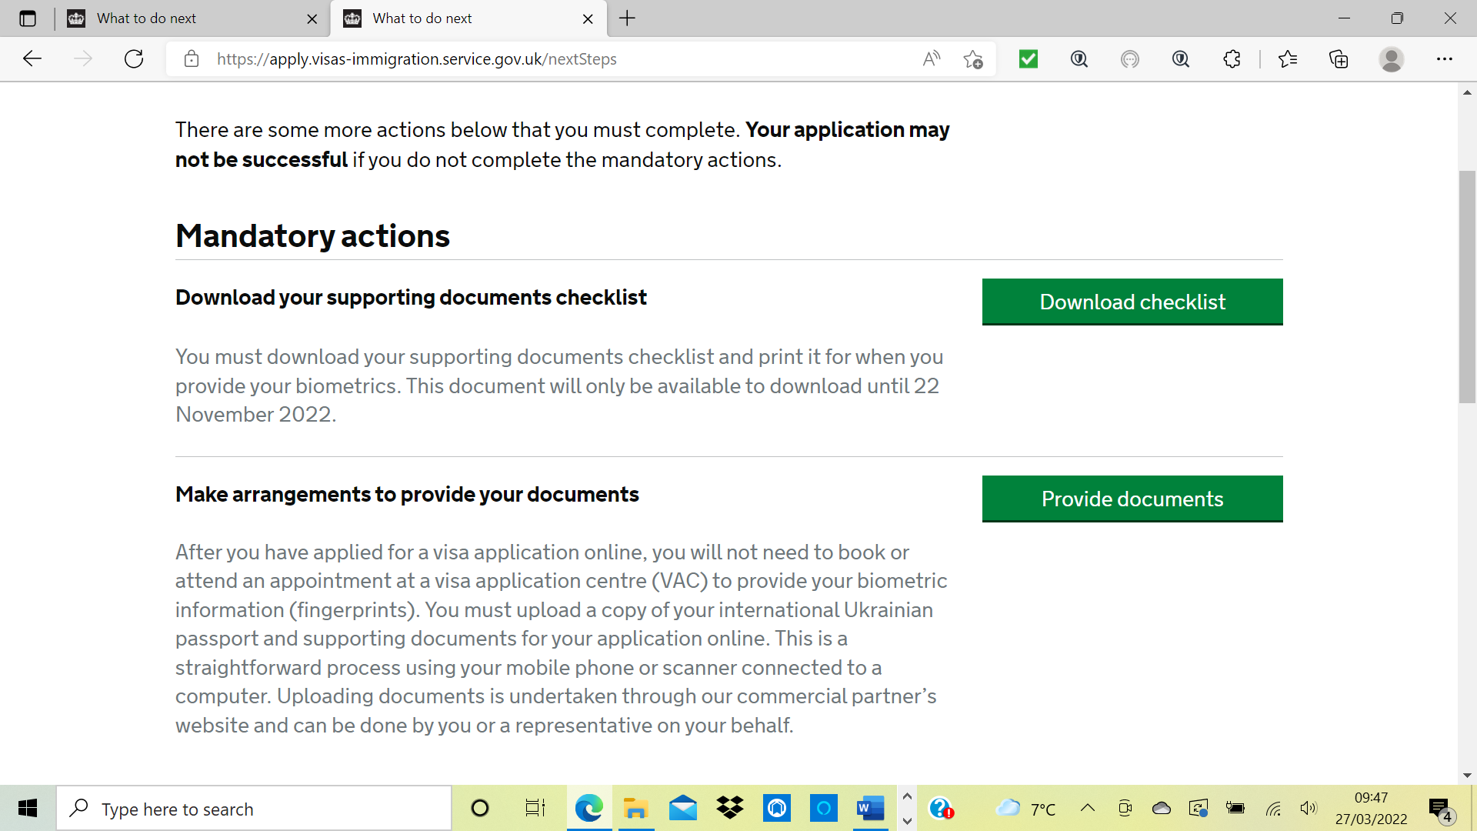
If you scroll down the page you can download your application if you wish to do so
Click
Provide Documents

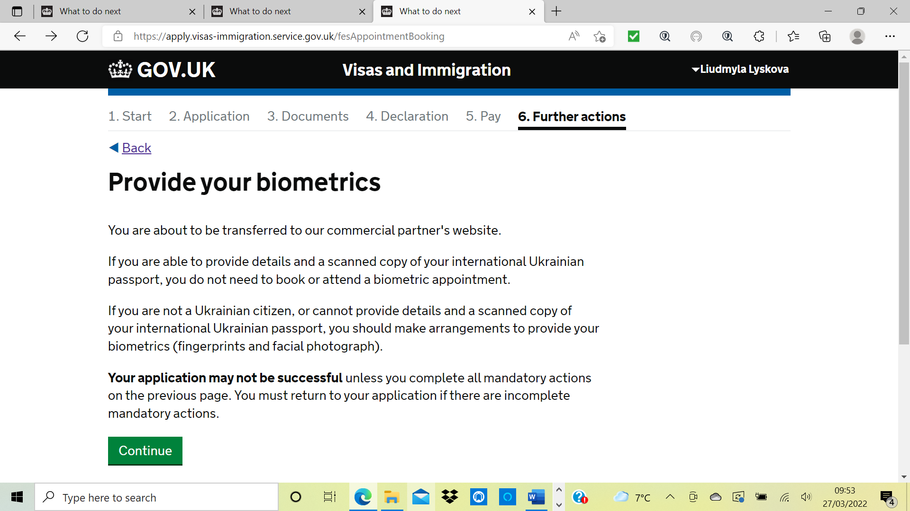
Click
Continue

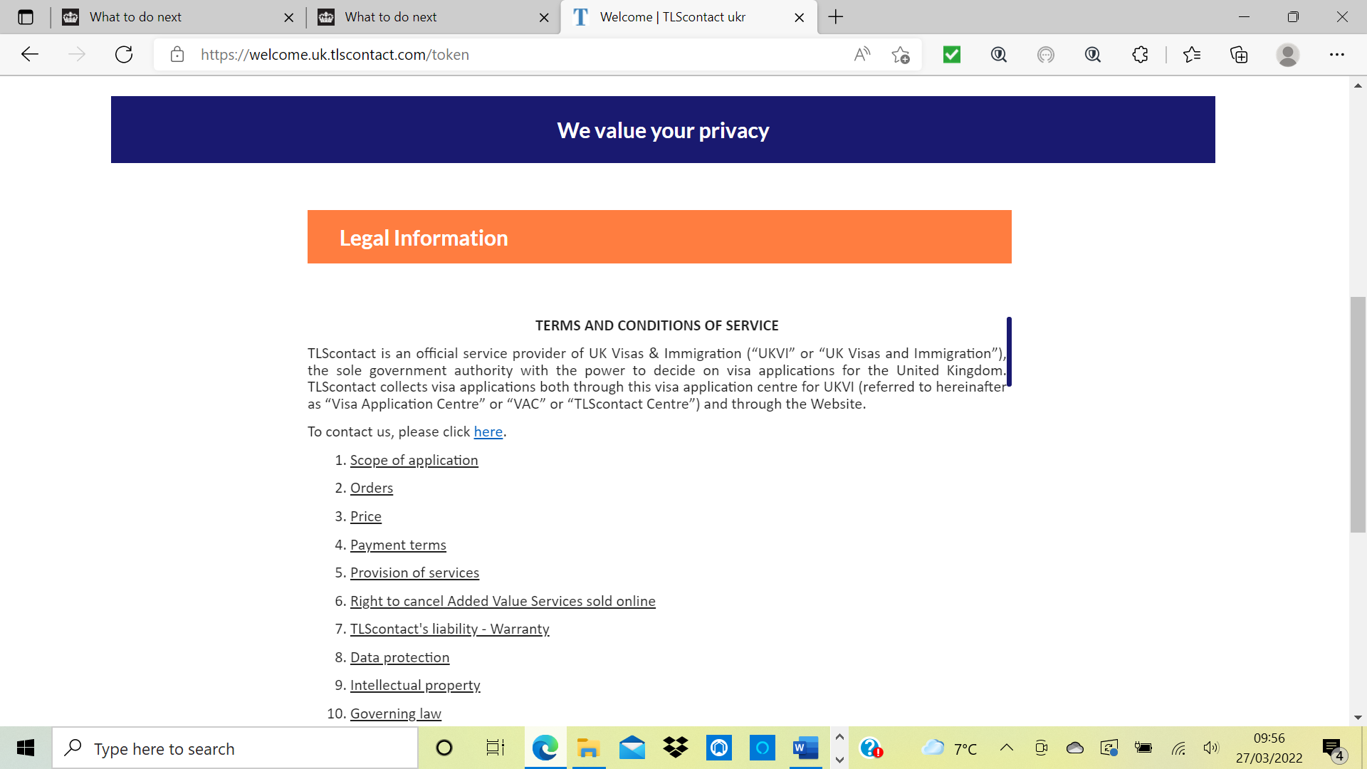
Scroll down page to
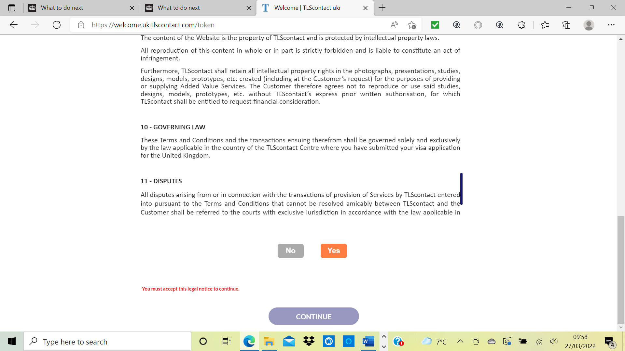
Select
Yes

Select
Continue

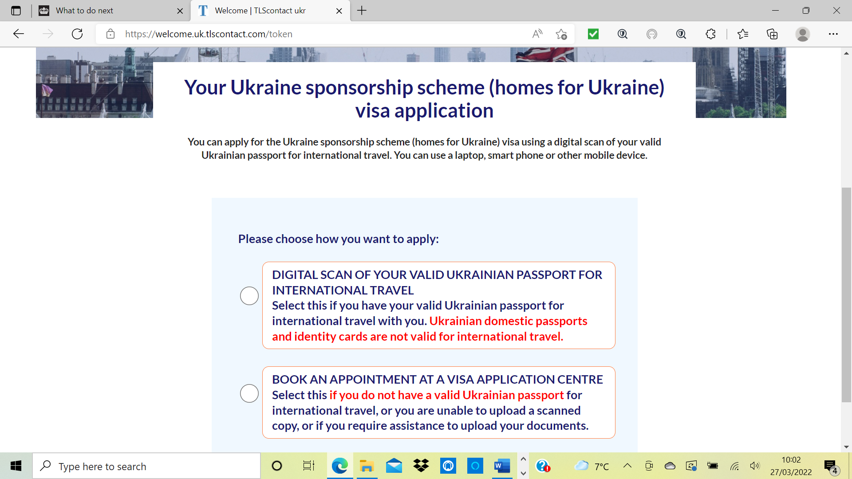

Initially it will not allow you to select digital scan so you will have to select book appointment options are Warsaw or Rzeszew suggest you ask person who you are sponsoring before hand if you are completing on their behalf.

It will take you through to another page if you are doing this for someone who has a passport then at this point you need to go into the email that gives you the link to your application and select Resume my old application if you do not have the passport you will need to follow the on screen prompts and book an appointment. Below is for those that have a passport.

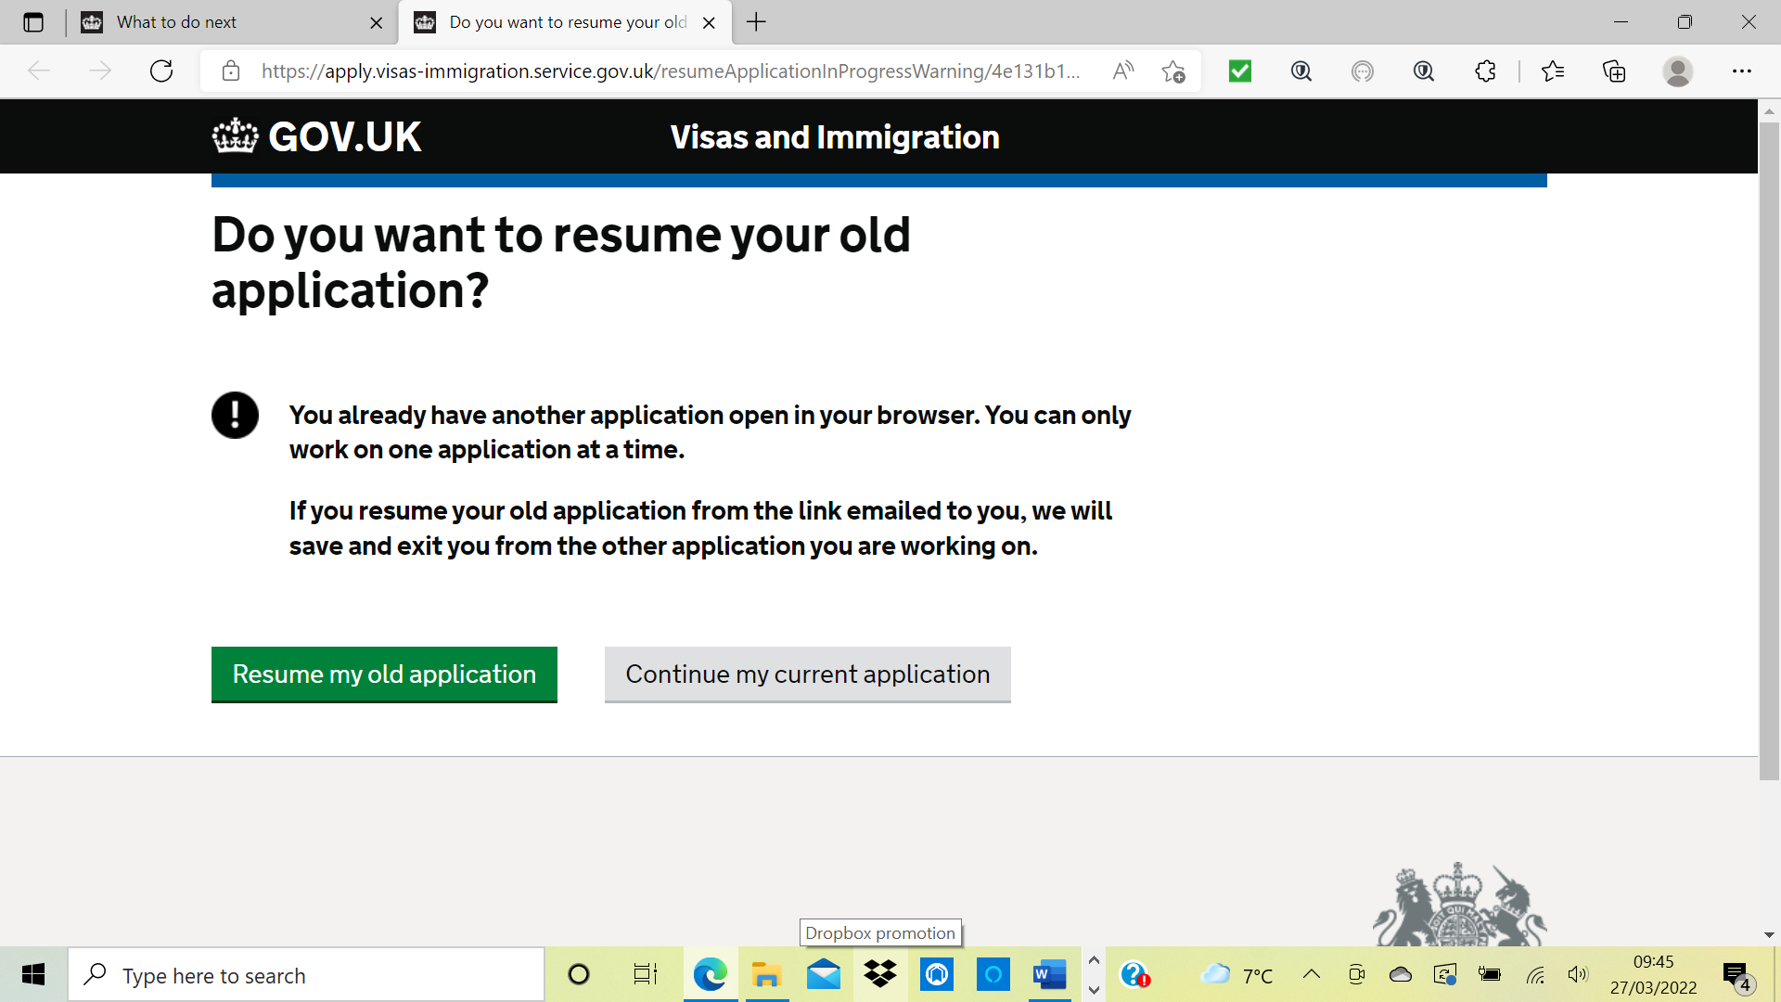
Select resume old application
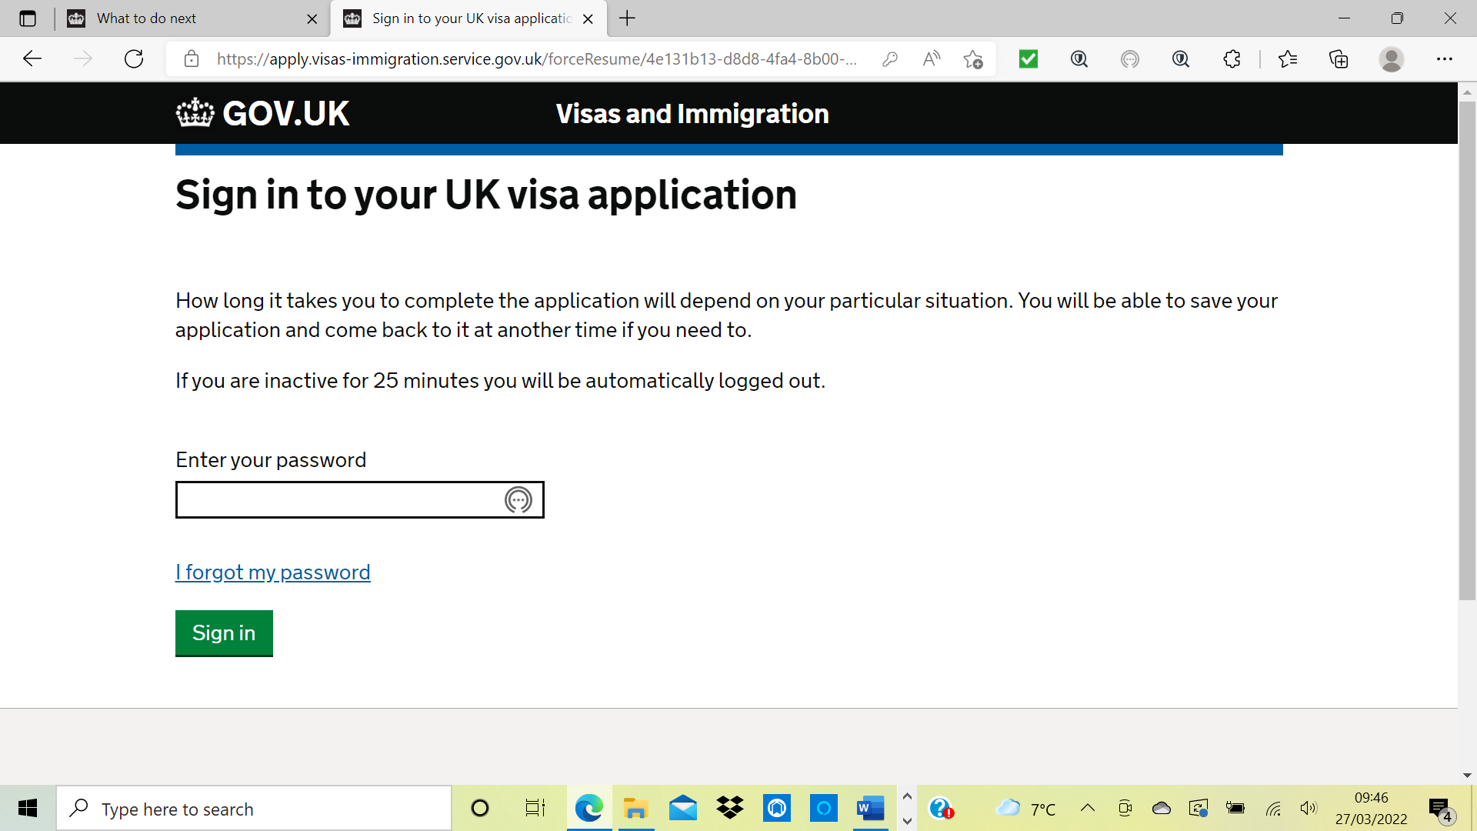

Enter password
Click onto
Sign in

If you scroll down the page you can download your application if you wish to do so
Click
Provide Documents

Don’t worry I have already provided the documents
Click
Continue

Scroll down page to
Select
Yes

Select
Continue

This time select digital scan and it will take you through to a screen where you can upload your pdf documents, the rest is easy, upload your documents and then submit them and you will get a screen that tells you
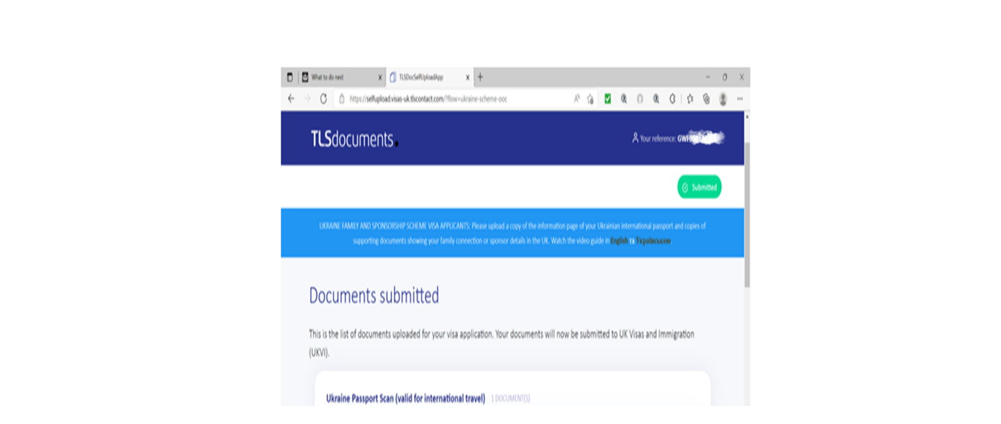
APPLICATION COMPLETE

And if you scroll down you will see all the pdf documents that have been submitted, then it’s a case of sitting back and waiting for the foreign office.

Below is the extract of continued instructions I got off facebook and those of you that do not have a passport or do have a passport will find it handy information
- Download your supporting documents checklist; gives you PDF download.
- Make arrangements to provide your documents; Takes you to a new portal.
- Agree to new portal terms and conditions.
- Confirm your identity (this screen has pre-populated your information).
- Choose your interest visa centre, it notes if you have biometric you do not need to attend visa centre, but you can’t continue without selecting one, so just select the nearest anyway even though you don’t need to attend.
- Choose how you want to continue: Digital upload or Book an appointment at a visa centre.
ANSWER: Digital upload
- Next is a drag and drop/upload screen to upload all supporting documents, again they MUST BE IN PDF FORMAT, no other format will be accepted, upload all documents BEFORE YOU CLICK SUBMIT, once you click submit you cannot go back to add something you forgot. So plese make sure EVERYTHING has been uploaded before clicking submit.
- You are advised to make sure all documents are in English and any translated documents must be certified. Honestly I think this is a copy/paste from the usual visa instruction and lacks the acknowledgement of the urgency/language barrier and ability to access translation facilities. Many have uploaded in Ukrainian only. It is worth noting within the form there is a free text box asking you to explain why you are unable to provide any key documents. Here I noted that letters from parents giving consent/utility bills and birth certificates were in Ukrainian only due to the aforementioned.

